**Intro**

For this analysis I wanted to focus on Zomato’s customers. The goal was to gain more insight on their demographics and see what segments we can separate them in. From the data set given I decided to separate users into three segments: age, occupation, and gender.

**User Demographics**

Results showed that the majority of Zomato users are male. Most users also reported that they are 22, 23, and 25 years old. The age with the highest number of users was 23. Additionally the top 3 occupations that users reported having were: student, employee, and self employed. The occupation that contained the most users was students. The city that reported having the highest number of users was *Santoshpur, Kolkata*. Based on these findings, I would advise marketing to target their advertising towards students. This can take place by holding advertising campaigns and handing out promotional vouchers on college campuses during the first week of a semester.

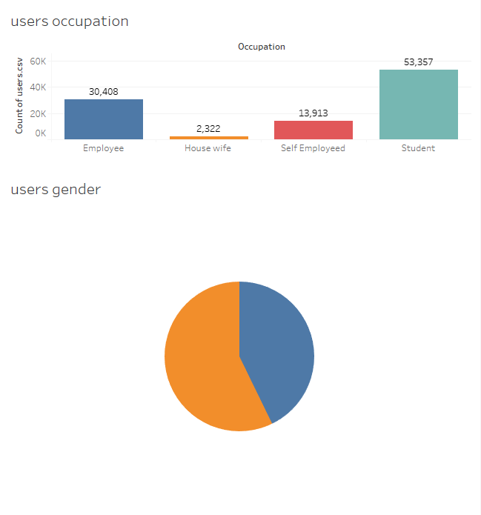

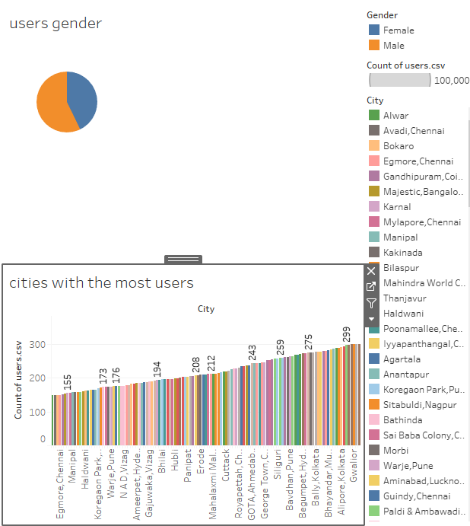

**User preferences**

The next thing that was studied during the analysis was cuisine preferences of users. Through the analysis it was reported that results on whether users preferred vegetarian or non vegetarian dishes were closely tied. In the end though, the majority of users report that they prefer to order vegetarian dishes. The next analysis done was to see what kind of cuisine was the most popular. The top 3 cuisines that were reported as popular amongst users were: *Bengalese, Italian*, *Mangalorean, Tibetan*, and *Mangalorean, South Indian*. Last, some of the dishes that were reported as the most popular amongst users were: Wok Tossed Bean Thread Noodles, Veg. Meal Combo 1, and Treat For 2 Combo. To find what dishes were the most popular, they were filtered to only show dishes with a rating of 4.0 or higher and to only show dishes from the top 3 cuisines. Based on these findings marketing should make these three cuisines their focus during advertisement campaigns

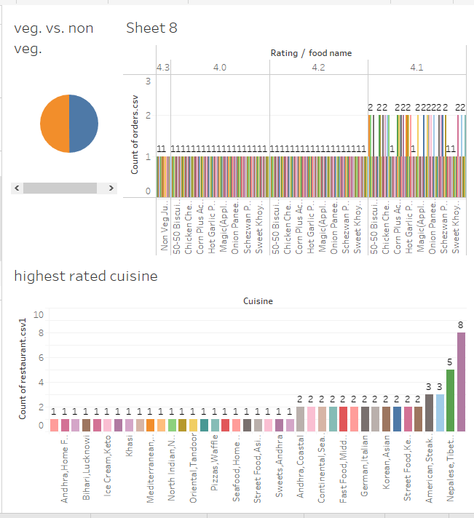

**Highest rated restaurants**

The last two variables that were analyzed were cities with the highest rated restaurants and some of the highest rated restaurants. Cities with the highest rated restaurants were filtered to only show cities with restaurants with a rating of “5.0”. Restaurants were also filtered to only show restaurants with the rating count of 1k or more. The findings showed that the cities with the most highly rated restaurants were: *Indiranagar, Bangalore*, *Bikaner*, and Sohna Road, Gurgaon. Based on these findings the marketing team should focus advertisement campaigns on these three cities and promote users in neighboring areas to order or visit these restaurants.

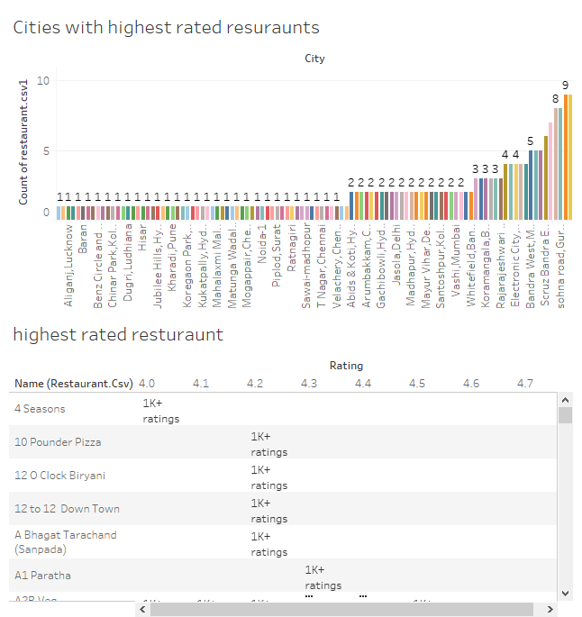

**Conclusion**

It was hypothesized that users’ purchasing patterns could be determined by 3 major factors.Based on the results we were able to find that there was a variable that showed strong correlations. Majority of users reported ordering vegetarian dishes. This can further be seen in the type of cuisine that is the most popular and restaurants that were the most popular and had the highest ratings. Based on where the majority of users are from and the location of popular restaurants this makes sense because many residents in the area choose to adhere to a vegetarian diet based on culture and religion. From the data that was gathered the marketing team should be advised to further target their advertisement towards young males who are currently students in these regions.

Link: https://public.tableau.com/views/Sprint7PublicTab/Dashboard1?:language=en-US&:sid=&:display_count=n&:origin=viz_share_link